Week 1: Introduction to Mobile Application Development
Student Name: Precious Jaiyesimi Eniola
Admission number: BIT/2024/39050
Course: Mobile Application Development
School/Faculty: Computing and Informatics, Mount Kenya University_
Program: Information Technology
Academic Year: 4th
Semester: First
Lecturer: Mr Nyoro

Task Completed
Challenge faced:

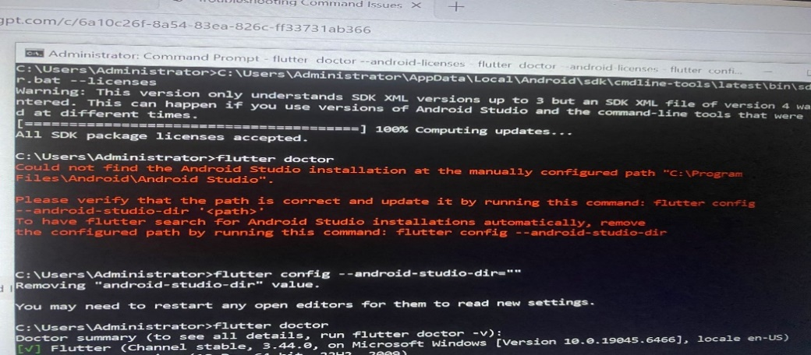
I found it difficult to set up the android studio tools and flutter was pointing at another Java path
Solution:
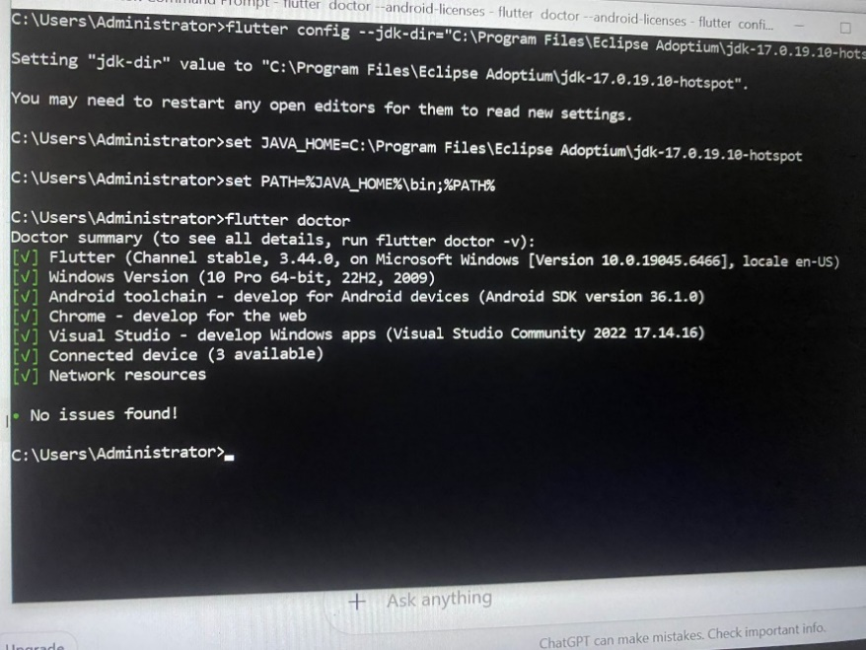
I eventually fixed it and set up all the environment
Then I Proceeded to create the App starting from Command prompt:
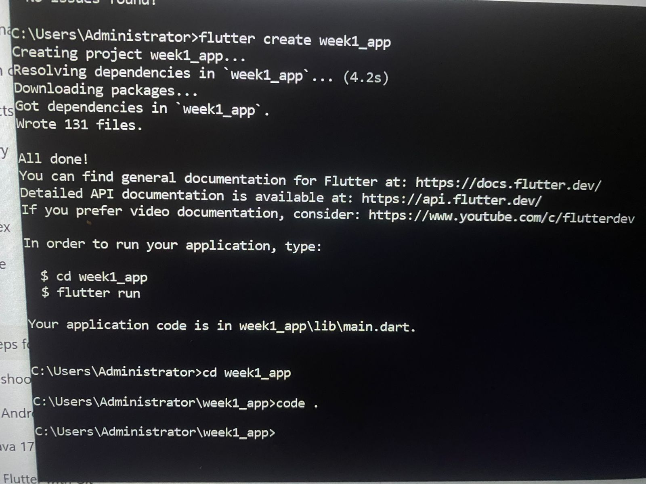

I was redirected to VS code and I ran flutter to start creating the app:
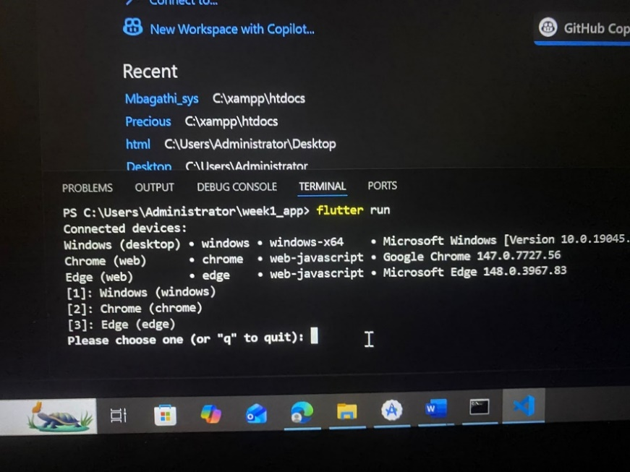
App created:
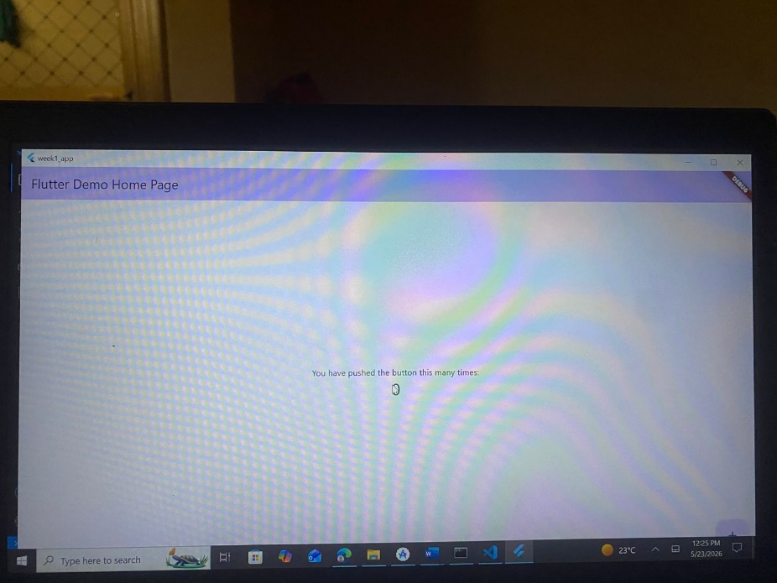

Then I Modified the app as instructed:
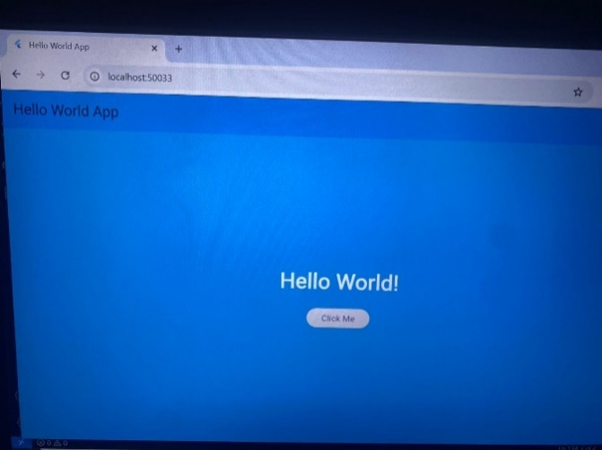

Tools/Software Used
- Flutter
- Java JDK 17
- Andriod studio
- Dart
- CMD

Personal Reflection
In Week 1, I set up the application environment, installed required tools, and initialized the project structure. I learned the basics of Flutter project setup, file organization, and running the app successfully. This week helped me understand how a mobile app begins from a clean foundation.

